# **DR. AMBEDKAR COLLEGE, DEEKSHABHOOMI,**

**NAGPUR**

**DEPARTMENT OF LAW**

**LEGAL AID CLINIC**

**FREE LEGAL AID AND LEGAL LITERACY PROGRAM**

**Date: 24th, 25th & 26th October 2023**

**Name of the Programme: FREE LEGAL AID AND LEGAL LITERACY PROGRAMME**

**Chief Guest: Hon’ble Shrimati Sameena Khan, Judge,**

**Industrial Court**

**Guest of Honour: Adv. Megha Burange, APP,**

**District Court, Nagpur**

**Organised by: Legal Aid Clinic, Department of Law**

**Co-ordinator of Legal Aid Clinic: Dr. Pratima Lokhande**

**Members of legal Aid Clinic: 1. Dr. Vaishali Sukhdeve**

**2.Miss. Shazia Bari**

**3. Ms. Sarika Kamdi**

**Number of Volunteers: 150**

**Name of Venue: Department of Law, Dr. Ambedkar College Deeksha Bhoomi, Nagpur**

**REPORT ON FREE LEGAL AID AND LEGAL LITERACY PROGRAMME**

Three days Free Legal Aid and Legal Literacy Program was organised by Legal Aid Clinic, Department of Law, Dr. Ambedkar College, Deekshabhoomi, Nagpur from 24th to 26th October 2023. Inaugural Ceremony was organised on 24th October 2023. The Program was Inaugurated at the holy land of Deekshabhoomi with aim to provide free legal aid to needy people and also to train the budding lawyers to understand and comprehend law. The Ceremony was graced by **Chief Guest, Hon’ble Shrimati Sameena Khan, Judge, Industrial Court, Nagpur** and Guest of Honour, Adv. Megha Burange, APP, District Court, Nagpur. On this occasion Dr. B. A. Mehere, Principal, Dr. Ambedkar College, Deekshabhoomi, Nagpur, Dr. H. V. Menon, Head of the Department of Law, Members of Param Pujya Dr. Babasaheb Ambedkar Smarak Samiti, Shri N. R. Sute, Dr. Rajendra Gavai, Shri. Vilas Gajghate, Adv. Pradeep Aglave, and all teaching and non-teaching staff were also present.

“Lawyers are Social Engineers and thus, law students should come forward to render Pro bono legal services to the marginalised and underprivileged sections of our society” said Chief Guest, Hon’ble Shrimati Sameena Khan, Judge, Industrial Court, Nagpur. Hon’ble Chief Guest also congratulated the organisers for taking such unique initiative inspiring the law students to cultivate empathy for others and for developing their legal acumen.

**Adv. Megha Burange, APP, District Court, Nagpur** was the Guest of Honour for the program. She shared her experiences with the students and encouraged them to spread legal awareness at the grassroot level

**Dr. B. A. Mehere, Principal**, Dr. Ambedkar College, Deekshabhoomi, Nagpur delivered welcome address and encouraged the organisers to continue with this tradition of inculcating good human values in future lawyers. **Prof. Dr. H. V. Menon,** **Head of the Department of Law** also addressed the gathering.

The Introductory remarks were delivered by **Dr. Pratima Lokhande, Associate Professor and Coordinator Legal Aid Clinic** in which she spoke about legal awareness which will be created through personal interaction, through pamphlets and posters, and through various other similar modes. The aided person will be given legal advice as per the requirement of the situation and case, by the final year students with the help of practising visiting faculty.

Students briefed the pilgrims at Deeksha Bhoomi about various schemes for girl child, rights of women and children, right to education, right to information Sukanya yojanas and other like yojanas introduced by the government.

Mrs. Ashwini Kulkarni, Visiting Faculty read a detailed report on the past activities undertaken by Legal Aid Clinic. Introduction of the Guest were done by Ms. Shazia Bari, Assistant Professor, Member Legal Aid Clinic. Dr. Rajendra Gavai, Member of Param Pujya Dr. Babasaheb Ambedkar Smarak Samiti also addressed the students.

Final year student Ms. Anjali Tamshettiwar conducted the program. Ms. Sarika Kamdi, Assistant Professor and Member of Legal Aid Clinic proposed the Vote of Thanks. All the faculty members of the Department were prominently present for the program. Dr. Vaishali Sukhdeve, Assistant Professor and the Member of Legal Aid Clinic and the students of the Department worked hard for this program.

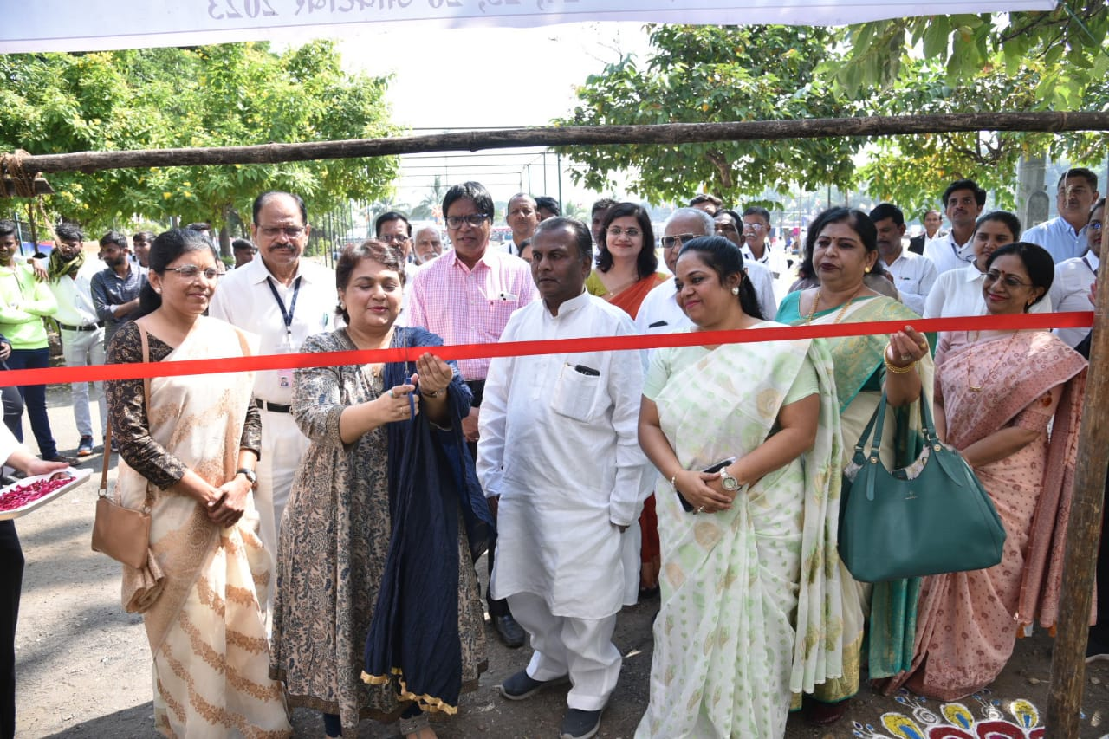

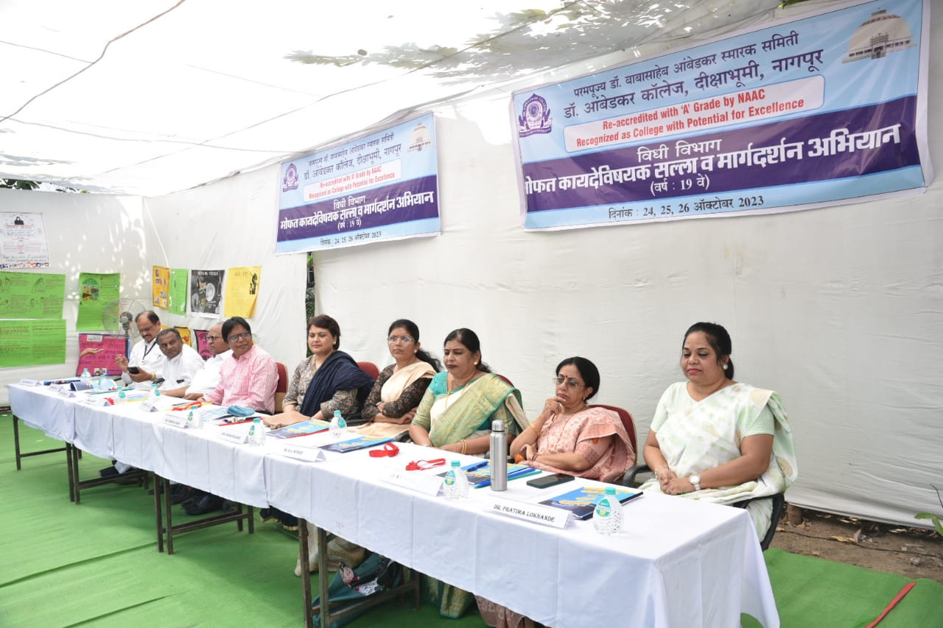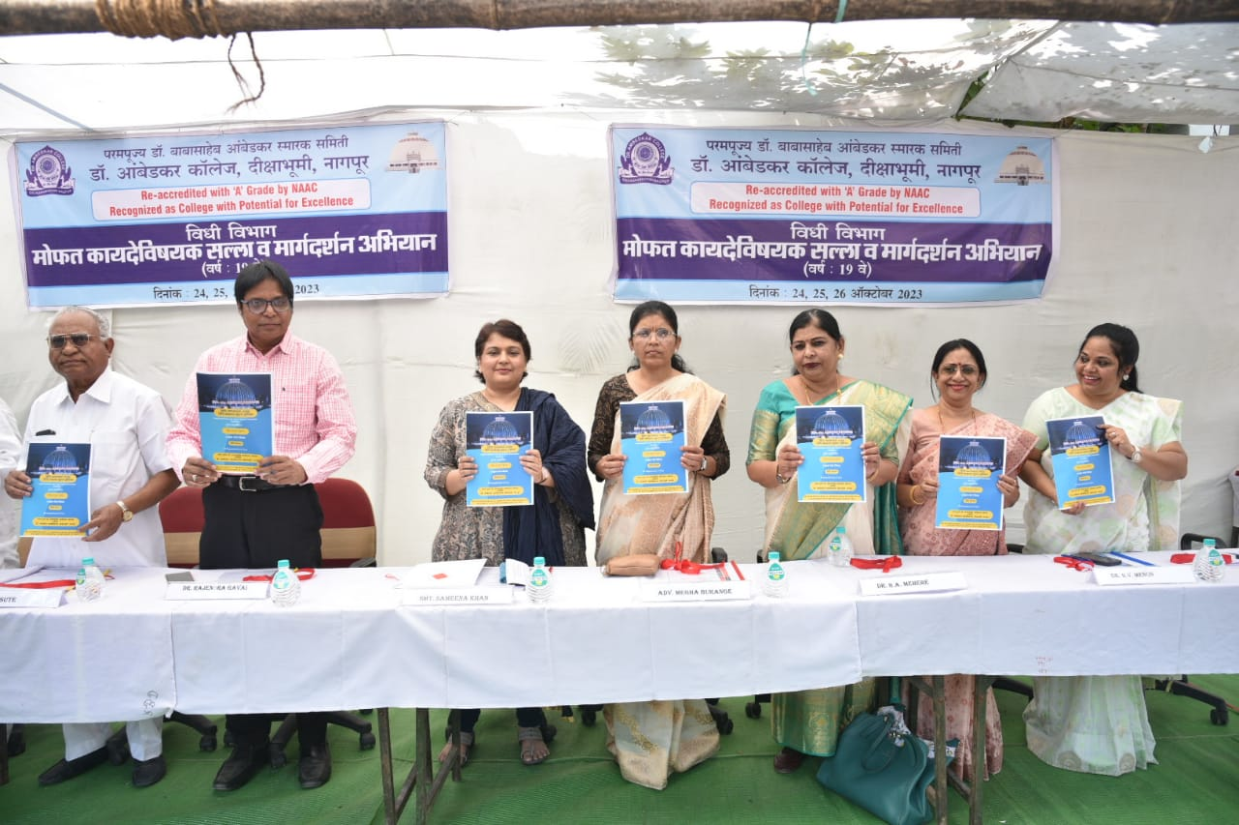

**Inauguration and Release of Booklet**

**PRESS NOTE**

*वकील हे वंचितांना न्याय देणारे सामाजिक अभियंते*  
- न्यायाधीश समीना खान यांचे प्रतिपादन  
- डॉ. आंबेडकर कॉलेजच्या विधी विभागातर्फे दीक्षाभूमीवर अनुयायांसाठी निःशुल्क मार्गदर्शन शिबिर...  
- 'मटा' नागपूर; शुक्रवार, २७ ऑक्टोबर १०२३

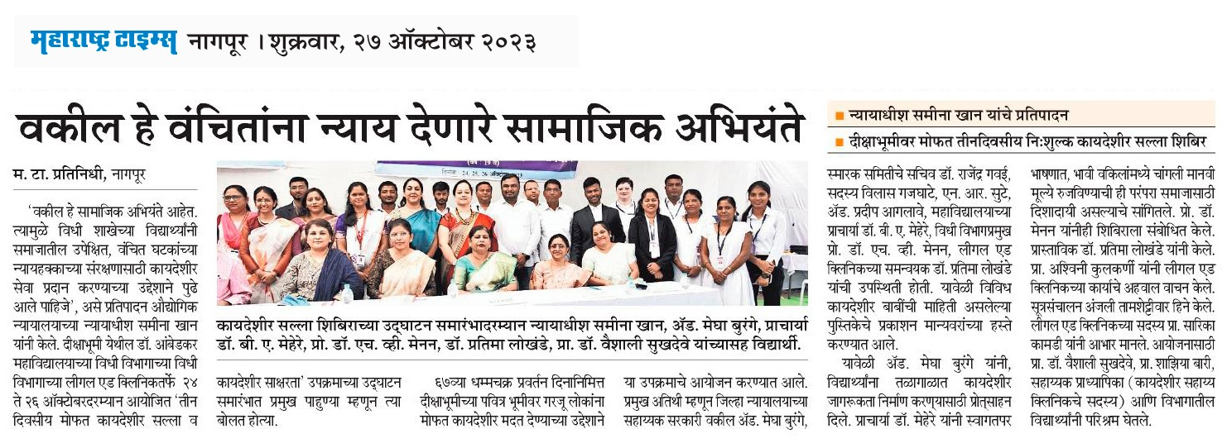

**GLIMPSES OF FREE LEGAL AID AND LEGAL LITERACY PROGRAMME**

